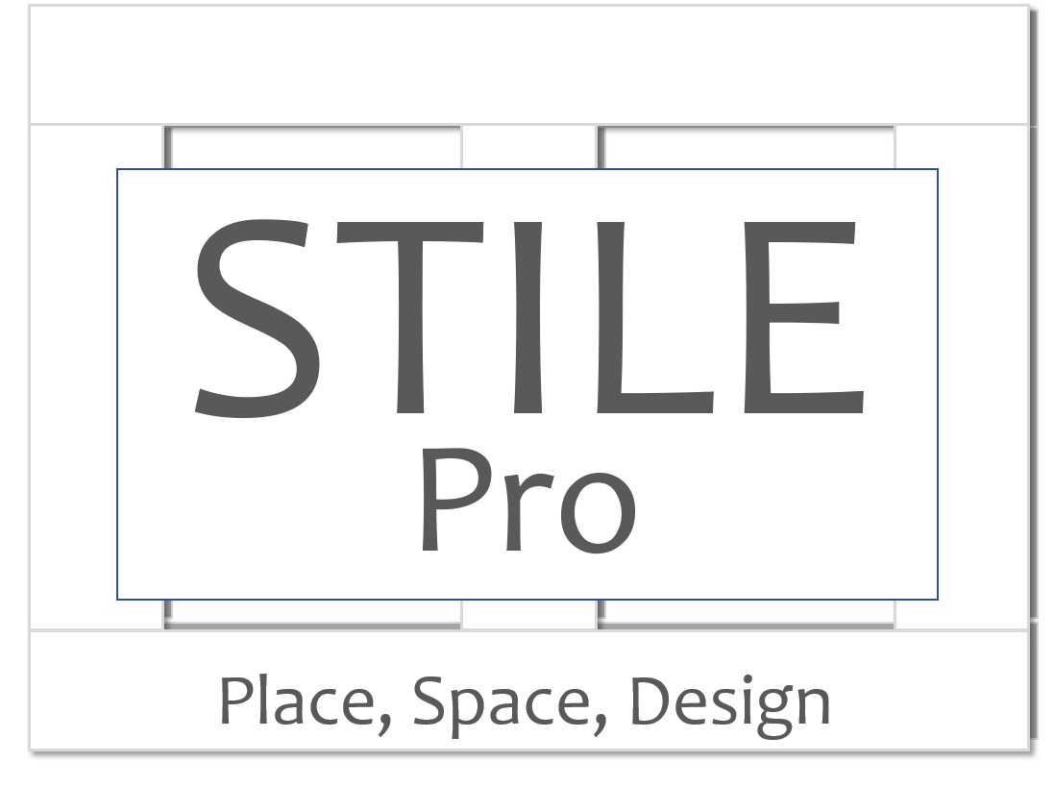 | Member Application

Thank you for applying for membership in STILE Pro. Please fill out this application email to anita@stile-studio.com. We will review your application and get back to you within 72 hours.
Membership is based on the individual, each person joining will need to fill out an application. Membership is non-transferrable. Contact Anita if you have questions about multi-person memberships.

The following questions will be listed on the public member page of the STILE website.
Name

Firm Name and Contact Information (website, phone, general email)

Category of Business (see list below)

Business Categories
Interior Design/Decorating/Staging/Organizing
Architecture/Building Design
Building/General Contractor/Building Trade Services
Design Trade Services (upholstery, painting, wallpaper, etc)
Product Vendor/Manufacturer
Landscape Design/Build/Gardening
Retail Furniture and Home Goods
Handcrafted and/or Custom Furniture and Home Goods
Artist/Artisan
Student
Educator
Real Estate Services
Design Industry Press
Other Trade Professional

Brief Description of Business or Professional Profile (about 50 words)*

The following questions will be listed on the members-only section of the website:

Member Contact Information (phone/email as desired)

Expanded Description of Business or Personal Profile (200-300 words, include specifics on services, expertise, etc.)

What type of project and or client best fits your business?

Do you work with any partners that you’d like to recommend to the group?

Why are you passionate about what you do?

Tell us a little more about yourself outside work.

The following questions will help us get to know you better and develop additional programs and services. Answers to these questions are private and won’t be published anywhere. Feel free to skip any questions that aren’t relevant.

Who referred you as a member?

What professional organizations do you/have you belonged to?

What do you find most valuable about these memberships?

What do you find least valuable?

Are you registered with any licensing organizations? AIA, ASID, etc

Are you interested in being or connecting with a mentor? What areas of business would you like mentoring on or do you have specific expertise in?

Are you interested on speaking to a member group on a business-skills related topic? For example: “What I’ve learned about hiring strong employees” or “Developing a process that the team will follow”. Please give a brief overview.

Are you interested in participating in a giving-back project? Do you have any recommendations for organizations to get involved with?

Would you like to refer colleagues who you think would make good members? Please list name and contact information.

What is the most impactful thing STILE Pro could do to support the design/build/real estate industries in Austin? Your specific industry?

What do you hope to get out of your membership in STILE Pro?

Business Owners
How many staff members do you have? (full-time/contract)

Do you plan to expand, contract or stay the same size (staff/revenue) over the next year? Over the next 5 years?

Do you plan to expand in to new services or lines of business? Please explain.

What types of partnerships are you interested in?

What is your biggest business challenge?

Employees
Do you need additional training to advance in your career? Please explain.

Are you interested in starting your own business at some point?

What else can we do to help you get the most out of your career?

